**How to take our Team Stats CSV files to Postgres**

1. Make sure Docker Desktop is running locally
2. Run ‘docker-compose up’ in local folder containing docker-compose.yml file
3. Connect to Postgres using localhost:5050
4. Create Database in pgAdmin (Team_Stats_Example)
5. Create table under database using command line

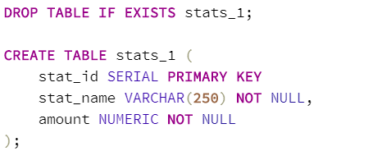

Import Data using import/export feature (be sure to check box for headers)

Key points to keep in mind when creating tables:

1. Headers need to match on CSV so let's use lower case and “_” as a space as a standard naming convention.
2. We can’t mix different types of data into one column, these will need to be put into different columns or normalized to be put into one column.

